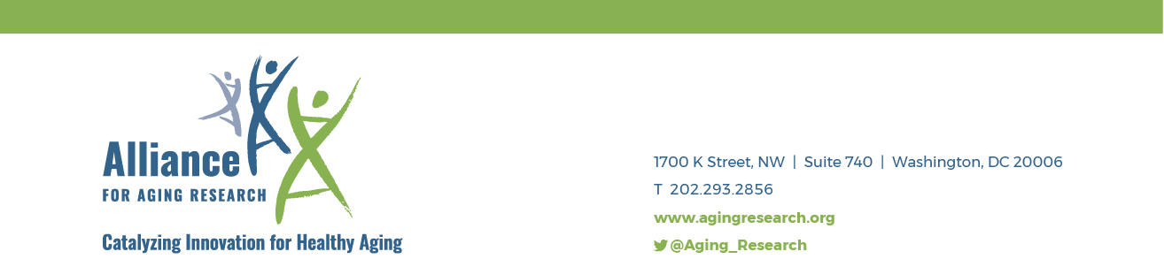

Extraordinary Opportunity for Patients and/or Family Caregivers to
Become Research Advisors

The Alliance for Aging Research’s Talk NERDY to Me Network empowers older adults and their family caregivers to collaborate with physicians and researchers on patient-centered outcomes research (PCOR) related to (1) Alzheimer’s disease, (2) heart valve disease, (3) atrial fibrillation, (4) chronic pain and/or disability, and (5) macular degeneration in adults age 65 years and older. To achieve this goal, we offer a two-week online workshop and mentoring program.

Beginning in early December, participants will meet three times a week, for two weeks from 12:00 PM - 1:30 PM Eastern Time, to learn from researchers in the field and each other. Participants will also complete assignments and have opportunities to collaborate online. The workshop will culminate in individualized action plans for each participant.

By completing the course, participants will learn the following:
- The purpose of—and best practices in—Patient-Centered Outcomes Research (PCOR);
- How to develop research questions meaningful to older adults and diverse backgrounds;
- Key scientific tools and concepts to better understand health research; and
- How to put this training to work.

At the Alliance, we strive to be a place where inclusion lives and diverse voices are valued.

As alum, our participants will receive our continued assistance in finding public and private advisory roles in research, policy, and health education-focused opportunities centered on improving outcomes in research and patient care.

We are looking for advocates who are:
- Engaged in advocacy in one of the priority health conditions.
- Excited to learn about how patients and family caregivers can engage as advisors in the research process. There is NO prior knowledge or expertise required.
- Able to participate in six 90-minute online sessions. You do NOT need to be tech savvy in any way; we will walk you through every step of the “online” process.
- Complete homework prior to each session. (No grading we promise!)

Participants successfully completing the workshop will receive a stipend of $1,500 and a Certificate of Completion for participating in the training.

Course Sessions Schedule
Session One: Monday, December 6, 2021

Session Two: Wednesday, December 8, 2021

Session Three: Friday, December 10, 2021

Session Four: Monday, December 13, 2021

Session Five: Wednesday, December 15, 2021

Session Six: Friday, December 17, 2021

How to Apply
Anyone who is engaged in advocacy in one of the priority health conditions, excited to learn about medical research, and willing to make full commitment to the two-week program, is encouraged to apply by emailing Ashley Leonard at aleonard@agingresearch.org.

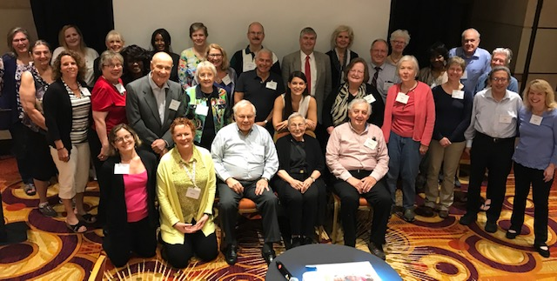
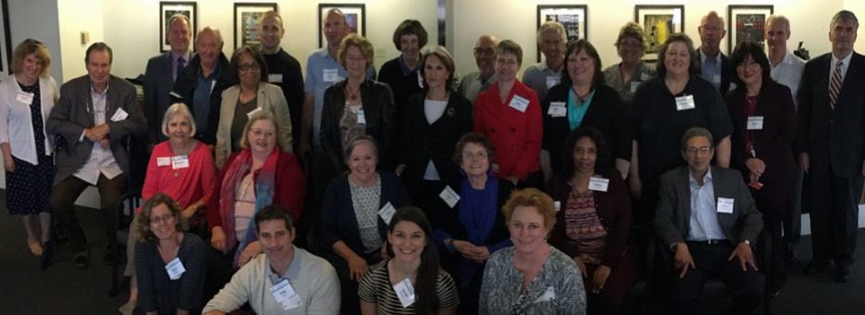

2018 – Chicago, IL | Second training
2017 – Washington, DC | Pilot training

Questions & Answers

What is patient-centered outcomes research?
Patient-centered outcomes research focuses on questions that are truly important to patients and their caregivers. To ensure that research is patient-centered, patients and caregivers engage in all aspects of the research process, from developing research questions to disseminating results.

What kind of topics will be covered?
Participants will learn the nuts and bolts of research. How are research questions developed? How does funding impact the work? How do researchers decide how to design a particular trial? Participants will also learn about the unique properties of patient-centered outcomes research. What does meaningful patient/caregiver engagement look like? How do we determine the extent to which a research topic matters to patients? What do research advocates actually do?

How would I use this training?
Research advocacy training empowers patients and caregivers. This training will help prepare advocates to serve as merit reviewers for organizations like the Patient-Centered Outcomes Research Institute or the National Institutes of Health; sit on research-related committees such as Institutional Review Boards; and partner with researchers in designing, implementing, or disseminating research. We also hope that participants bring the training back to their own communities.

Am I qualified?
If you are engaged in advocacy in one of the priority health conditions, excited to learn about medical research, and willing to make full commitment to the two-week program, then you are qualified!

How do I apply or learn more?
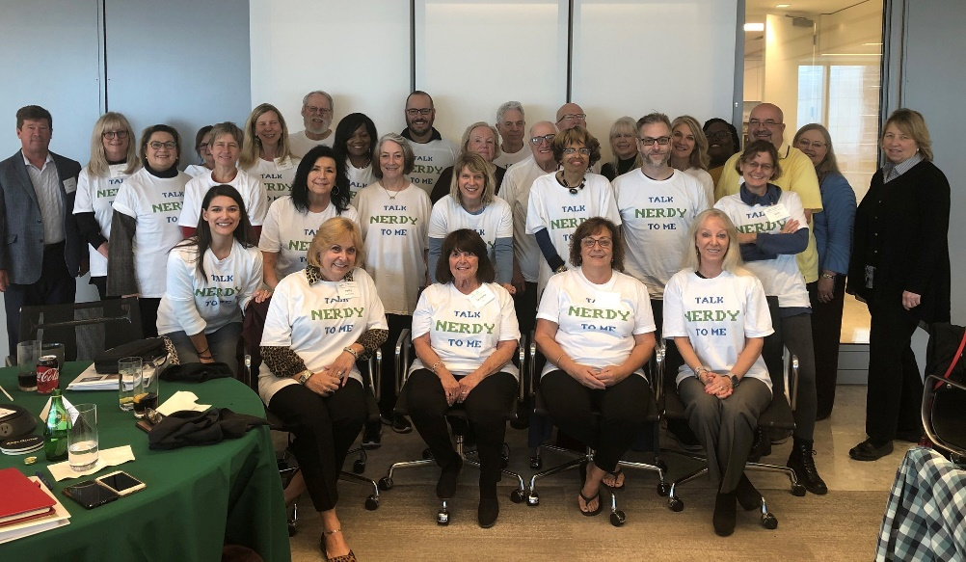
Contact Ashley Leonard at aleonard@agingresearch.org.
2019 – Dallas, TX | Third training

