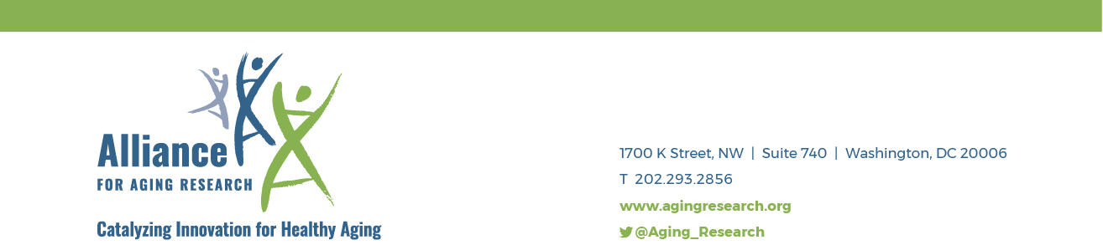

Opportunity for Researchers and Clinicians to Learn How to Establish/Expand Patient Engagement in CER Research

Since 2017, the Alliance for Aging Research’s Talk NERDY to Me network has addressed the underrepresentation of older adult patients and family caregivers in research advisory positions by placing network alum in patient-centered outcomes research (PCOR) efforts at the FDA, the DoD, PCORI, the NIH, the private sector, and in local comparative clinical effectiveness research (CER) projects. Engaging seniors with major chronic illnesses have opened a window into how real and perceived barriers impact access to effective interventions and services. However, throughout the four years that the Talk NERDY to Me training has been offered, the Alliance has noticed a lack of PCOR opportunities for the network’s alum.

The Talk NERDY to Me Network empowers older adults and their caregivers to collaborate with physicians and researchers on PCOR related to (1) Alzheimer’s disease, (2) heart valve disease, (3) atrial fibrillation, (4) chronic pain and/or disability, and (5) macular degeneration in adults age 65 years and older. Additionally, the Talk NERDY to Me network has a 2021 focus to include researchers and providers in our annual training who would be interested in establishing meaningful PCOR engagement opportunities within their work. To achieve this goal, we will offer a two-week online workshop.

Beginning in early December, participants will meet three times a week, for two weeks from 12:00 PM - 1:30 PM Eastern Time, to learn from researchers in the field and each other. Participants will also complete assignments and have opportunities to collaborate online. The workshop will culminate in individualized action plans for each participant.

By completing the course, participants will learn the following:
- The purpose of—and best practices in—Patient-Centered Outcomes Research (PCOR);
- How to work with older adult patients and family caregivers to develop research questions meaningful to them; and
- How to create and incorporate the older adult patient and family caregiver perspective throughout PCOR projects.

As a participant you will receive direct access to the Talk NERDY to Me Advisory Council, a network of patients, researchers, payers, and industry representatives that aid in sculpting the program and encourage application of the teachings post completion.

At the Alliance, we strive to be a place where inclusion lives, and diverse voices are valued. Our goal is to actively educate researchers and providers who commit to establishing meaningful, diverse PCOR engagement opportunities for older patients and family caregivers within their work.

We are looking for researchers and providers who are:
- Engaged in research or clinical care in one of the priority health conditions.
- PCORI applicant for CER funding, or those interested in expanding PCOR opportunities within existing CER programs.
- Able to participate in six 90-minute online sessions.
- Complete a short amount of homework prior to each session.
- Committed to creating new/additional PCOR opportunities for older adult patients and family caregivers!

Participants successfully completing the workshop will receive a stipend of $1,500 and a Certificate of Completion for participating in the training.

Course Sessions Schedule
Session One: Monday, December 6, 2021
Session Two: Wednesday, December 8, 2021
Session Three: Friday, December 10, 2021
Session Four: Monday, December 13, 2021
Session Five: Wednesday, December 15, 2021
Session Six: Friday, December 17, 2021

How to Apply
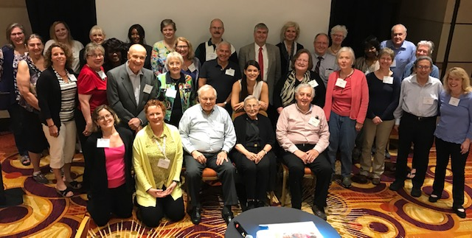
Anyone who is engaged in research or clinical care in one of the priority health conditions, and willing to make a full commitment to the two-week program, is encouraged to apply by emailing Ashley Leonard at aleonard@agingresearch.org.
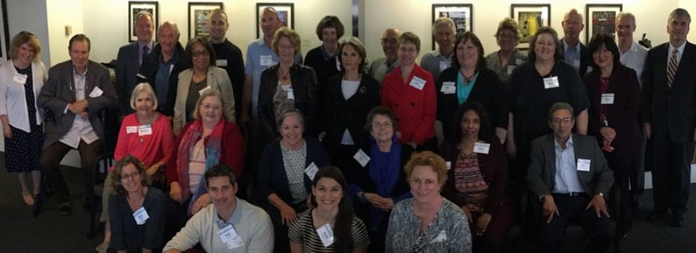

2018 – Chicago, IL | Second training
2017 – Washington, DC | Pilot training

Questions & Answers

How would I use this training?
There are many ways researchers and clinicians can engage patients and family caregivers in their research. This training will highlight best practices when engaging with patients and family caregivers and how to apply their perspectives throughout the PCOR projects to maximize the value of their participation. We also hope researcher and clinician participants bring the training back to their own communities to continue education and create more opportunities.

Am I qualified?
If you are engaged in research in one of the priority health conditions, excited to create new/additional PCOR opportunities, and willing to make full commitment to the six-week program, then you are qualified!

How do I apply or learn more?
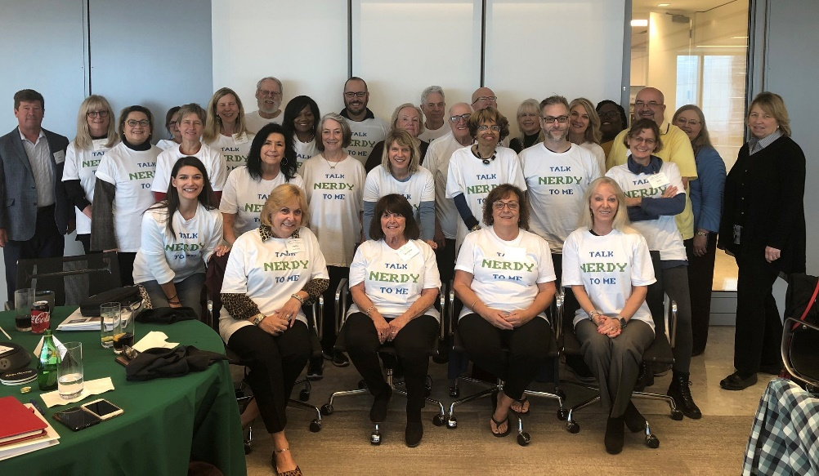
Contact Ashley Leonard at aleonard@agingresearch.org.
2019 – Dallas, TX | Third training

